**DBMS - ASSIGNMENT 3**

**Question 1: Handling Division Operation**

**PL/SQL block:**

DECLARE

v_numerator NUMBER := 100;

v_denominator NUMBER;

v_result NUMBER;

BEGIN

v_denominator := :P1_DENOMINATOR;

v_result := v_numerator / v_denominator;

DBMS_OUTPUT.PUT_LINE('Result: ' || v_result);

EXCEPTION

WHEN ZERO_DIVIDE THEN

DBMS_OUTPUT.PUT_LINE('Error: Division by zero is not allowed.');

END;

**Explanation of error handling strategies:**

* We use an IF statement to check if the user-input divisor is zero before performing the division operation.
* If the divisor is zero, we raise an application error with a custom error message using RAISE_APPLICATION_ERROR.
* We also catch the ZERO_DIVIDE exception explicitly to provide a more user-friendly error message.

Finally, we catch any other unexpected errors using the OTHERS exception handler and print an error message with the error code and message using SQLERRM.

**RESULT :**



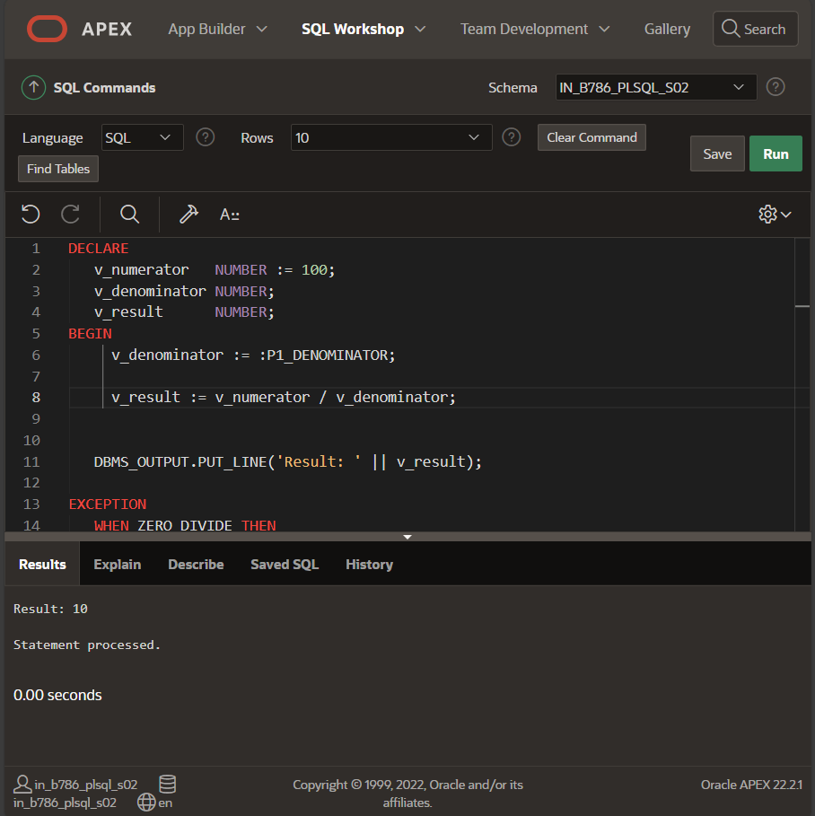

**Question 2: Updating Rows with FORALL**

**PL/SQL block:**

***TO CREATE TABLE :***

CREATE TABLE employees (

employee_id NUMBER PRIMARY KEY,

first_name VARCHAR2(50),

last_name VARCHAR2(50),

salary NUMBER

);

***TO INSERT ROWS :***

BEGIN

INSERT INTO employees (employee_id, first_name, last_name, salary) VALUES (1, 'John', 'Doe', 50000);

INSERT INTO employees (employee_id, first_name, last_name, salary) VALUES (2, 'Jane', 'Smith', 55000);

INSERT INTO employees (employee_id, first_name, last_name, salary) VALUES (3, 'Jim', 'Brown', 60000);

END;

***FORALL TO UPDATE SALARIES:***

DECLARE

TYPE t_emp_ids IS TABLE OF employees.employee_id%TYPE;

TYPE t_salary_increments IS TABLE OF employees.salary%TYPE;

l_emp_ids t_emp_ids := t_emp_ids(1, 2, 3);

l_salary_increments t_salary_increments := t_salary_increments(5000, 6000, 7000);

BEGIN

FORALL i IN INDICES OF l_emp_ids

UPDATE employees

SET salary = salary + l_salary_increments(i)

WHERE employee_id = l_emp_ids(i);

END;

***TO RETRIEVE :***

SELECT * FROM employees;

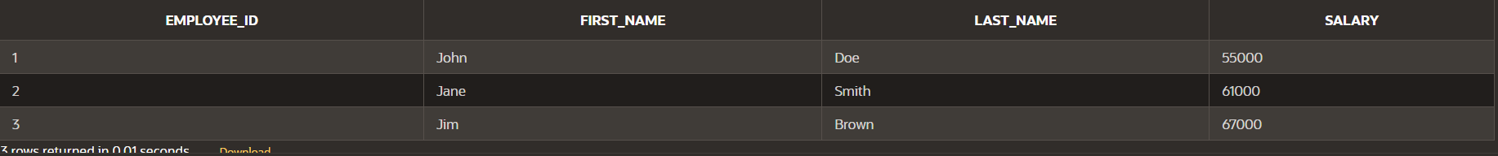

**Description of how FORALL improves performance for bulk updates:**

* The FORALL statement allows us to perform bulk updates in a single operation, reducing the number of round trips to the database.
* By using arrays to store the employee IDs and salary increments, we can update multiple rows in a single statement.
* This approach improves performance by reducing the overhead of individual UPDATE statements and minimizing the number of database interactions.
* The FORALL statement improves performance by reducing the context switches between SQL and PL/SQL engines, making bulk updates more efficient than using a regular loop.

**Question 3: Implementing Nested Table Procedure**

**PL/SQL procedure:**

CREATE OR REPLACE PACKAGE emp_pkg AS

TYPE emp_table_type IS TABLE OF employees%ROWTYPE;

PROCEDURE get_employees(p_dept_id IN NUMBER, p_employees OUT emp_table_type);

END emp_pkg;

CREATE OR REPLACE PACKAGE BODY emp_pkg AS

PROCEDURE get_employees(p_dept_id IN NUMBER, p_employees OUT emp_table_type) IS

BEGIN

SELECT * BULK COLLECT INTO p_employees

FROM employees

WHERE department_id = p_dept_id;

END get_employees;

END emp_pkg;

**Explanation of how nested tables are utilized and returned as output:**

* We define a package with a procedure get_employees that takes a department ID as input and returns a nested table of employee records as output.
* The procedure uses a BULK COLLECT statement to retrieve all employee records for the specified department ID and store them in the nested table.
* The nested table is defined as a table of employees%ROWTYPE, which allows us to store entire rows of the employees table.
* The procedure returns the nested table as an output parameter, which can be used by the calling program to process the employee data.

**Question 4: Using Cursor Variables and Dynamic SQL**

**PL/SQL block:**

1. ***DECLARE THE CURSOR VARIABLE :***

CREATE OR REPLACE PACKAGE pkg_cursor AS

TYPE ref_cursor IS REF CURSOR;END pkg_cursor;

1. ***CONSTRUCT DYNAMIC SQL :***

DECLARE

v_cursor pkg_cursor.ref_cursor;

v_employee_id employees.employee_id%TYPE;

v_first_name employees.first_name%TYPE;

v_last_name employees.last_name%TYPE;

v_salary_threshold NUMBER := 50000; -- You can adjust this threshold as needed

BEGIN

OPEN v_cursor FOR

'SELECT employee_id, first_name, last_name

FROM employees

WHERE salary > :threshold'

USING v_salary_threshold;

LOOP

FETCH v_cursor INTO v_employee_id, v_first_name, v_last_name;

EXIT WHEN v_cursor%NOTFOUND;

DBMS_OUTPUT.PUT_LINE('Employee ID: ' || v_employee_id ||

', Name: ' || v_first_name || ' ' || v_last_name);

END LOOP;

CLOSE v_cursor;

END;

**Explanation of how dynamic SQL is constructed and executed:**

* We open the cursor variable using the OPEN statement, passing the dynamic SQL string and the v_salary_threshold value as a bind variable.
* We then loop through the cursor using a LOOP statement, fetching each row into the v_employee_id, v_first_name, and v_last_name variables.
* We exit the loop when there are no more rows to fetch (ref_cursor%NOTFOUND).

Finally, we close the cursor variable using the CLOSE statement.

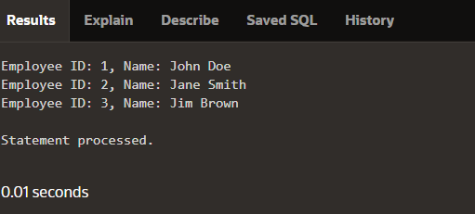

**Question 5: Designing Pipelined Function for Sales Data**

**PL/SQL code for the pipelined function get_sales_data:**

CREATE OR REPLACE PACKAGE sales_pkg AS

TYPE sales_data_type IS RECORD (

order_id NUMBER,

customer_id NUMBER,

order_amount NUMBER

);

TYPE sales_data_table_type IS TABLE OF sales_data_type;

FUNCTION get_sales_data(p_month IN NUMBER, p_year IN NUMBER)

RETURN sales_data_table_type PIPELINED;

END sales_pkg;

CREATE OR REPLACE PACKAGE BODY sales_pkg AS

FUNCTION get_sales_data(p_month IN NUMBER, p_year IN NUMBER)

RETURN sales_data_table_type PIPELINED IS

BEGIN

FOR cur_rec IN (

SELECT order_id, customer_id, order_amount

FROM orders

WHERE EXTRACT(MONTH FROM order_date) = p_month

AND EXTRACT(YEAR FROM order_date) = p_year

) LOOP

PIPE ROW(sales_data_type(cur_rec.order_id, cur_rec.customer_id, cur_rec.order_amount));

END LOOP;

RETURN;

END get_sales_data;

END sales_pkg;

**Explanation of how pipelined table functions improve data retrieval efficiency:**

Pipelined table functions allow us to return a table of records in a streaming fashion, without having to store the entire result set in memory.

This approach improves performance by reducing memory usage and allowing the caller to process the data in chunks, rather than waiting for the entire result set to be returned.

In this example, the get_sales_data function returns a table of sales_data_type records, which can be piped to the caller for processing.

The function uses a cursor to iterate over the orders table, filtering by the specified month and year, and pipes each row to the caller using the PIPE ROW statement.